**Detailed Overview of Research**

**Title: Identification and Resolution of Interpenetration Regions of Composite Tow Surface Meshes using Different Data Representation Types**

# Problem statement

As the usage of computational analysis for composite design becomes increasingly more popular, the desire to create and test textile composite materials is increasing as well. Previous research and study has been conducted using idealized woven textile geometries that lack the realism of imperfect woven composite tows. Currently, one set of software, Virtual Textile Morphology Suite, has been developed by Eric Zhou of AFRL and creates comparatively more realistic woven composite geometries. The method used to create these geometries is called the Digital Chain method and is published work. For most analyses, a filament (bundles of fibers) discretization of the tow is too complex to be analyzed, so instead, a surface representation of the tows is created so that homogenized properties can be applied. This representation is an approximation of the fiberized tow. When theses surfaces are created, small regions of interpenetrations are formed where the surfaces cross into each other. This creates two problems: 1.) a physically impossible occupation of the same space concerning the tows and 2.) incompatibility of the mesh resulting from these meshes crossing through each other.

This research will identify the regions of interpenetrations between two tows and attempt to find a solution to correct the interpenetration regions.

# Description of Data Types

For VTMS, there are two types of data formats.

## Standard Tow Format

The data stored in VTMS, which is covered here is a standard tow format that stores information for the tow. While a file output for a simple exported description of this data (.stw) can be saved as a file, it is far less descriptive.

The layout of the description of the surface geometry for a standard tow is stacks (cross sections) of the tow that are outlined by nodes. The number of nodes describing the cross-section outline is user defined. The tow is further defined by multiple cross-sections along the tow path. Each node in a stack is stored with its cartesian location, and outward normal from the tow surface. VTMS also stores triangles that connects the stacks that can be visualized as a triangular mesh. Below is a sketch.



VTMS has the availability to export this data as an .stw file. However, most of the data is not transferred and the .stw file simply holds node location data and which stack it belongs to. Therefore, any strategy that uses the standard format is much more useful inside of VTMS where it can access all stored information.

## Clipped Tow Format

VTMS can also store what is called a clipped tow. A clipped tow is the result of using VTMS’ clipping region on a standard tow. This format is more similar to a surface mesh data description as it stores information such as node location and surface polygon connectivity. The surface polygons can be either triangles, quadrilaterals, or any number sided polygon higher, although it is unusual to have a polygon with more than 4 sides. This format also stores the outward normal for each surface polygon. This format loses all stack information and instead relies on purely surface representation of the data. An illustration is shown below.



This data can also be exported like the .stw into the .ctw format. This format stores node location and outward normal. It also stores polygons such that the number of edges is known, and what nodes make up the corners of the surface polygon. This makes the format much more similar to typical surface mesh data storage than the previous data structure.

# Introduction to Algorithms

The main topic of this research is the identification and resolution of interpenetrating regions of tow surfaces. The surfaces are created by VTMS (for this study) and are stored using the formats previously discussed. Three main strategies have been developed for identifying and resolving these regions. They are discussed in their entirety below and make use of the two data formats.

# Discrete Surface Mesh Solution (Direct Use of Surface Mesh Strategy)

The first attempts to solve the surface mesh interpenetration issues was to start with the surface mesh returned from VTMS and attempt to solve the interpenetrations geometrically and without the use of any external aid. What follows is a descriptive outline.

## Detection of Interpenetrations

A method for interpenetration detection was already in place. However, a new one was implemented after it was discovered that the existing method was not entirely accurate.

Method:

1. Determine if any two tows are in proximity by using a bounding box (max dimensions) for each tow and evaluating if the box intersects with another tow bounding box.
2. If 1. Returns true, then for the two tows identified as being near each other, the intersection algorithm begins

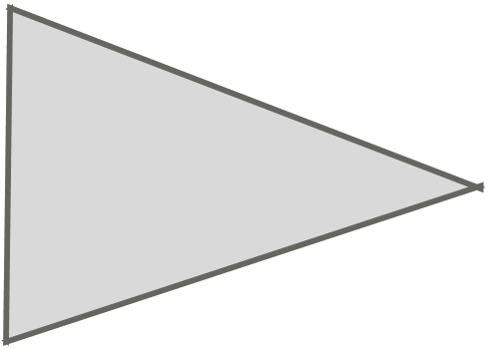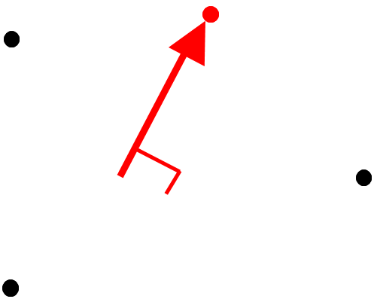

* 1. Algorithm starts by selecting a tow (called **tow A**) via a loop containing the two tows interpenetrating and begins looping over the **tow A** surface stack nodes for each stack.
  2. For the **tow A** node, the algorithm loops over **tow B** surface elements (triangular)
  3. For each element, the vector from the **tow A** node to the average location of the **tow B** surface element nodes (also called the interior point) is calculated
  4. The vector is then projected along the outward normal of the surface element
  5. The dot product of the two vectors is calculated
  6. If the dot product is negative, the node is on the internal side of the surface element with respect to **tow B**, indicating it is interpenetrating
  7. If the node is interpenetrating, it is given an ID number that tells VTMS it is interpenetrated

1. After the first tow is looped over, tow 2 undergoes the same process, collecting all of the interpenetrated nodes from each tow.

## Eliminate Interpenetration regions

Once the interpenetrated nodes are identified for each tow, a solution was implemented to solve this interpenetration. The initial algorithm in VTMS was slightly altered, and the differences will be discussed.

### Method 1: Artificial contact surface

This method occurs inside of VTMS and uses the standard tow format (not the .stw exported version of the data) of a tow mesh. The algorithm works by first identifying all interpenetrating surface nodes by the detection algorithm discussed previously. The algorithm then calculates the average of all of the interpenetration nodes and uses this point, along with a vector that is determined to be perpendicular both tow paths in the area of the interpenetration, to create a flat surface to pull the interpenetrating nodes to. This establishes a surface that is shared by both tows that will be referred to as a “contact surface”. The details of this algorithm are as follows:

1. Using all of the collected penetration nodes from the two tows, the algorithm begins by calculating the average location of all the nodes. This acts as the central point of the interpenetration.
2. The solution then determines which tow stacks contain the penetrated nodes that are involved for each tow for the penetration region.
3. The determined tow stacks are used to calculate an average tow path direction for each tow.
4. Using the tow paths, a cross-product is calculated to determine a direction that is perpendicular to both tow paths
5. This perpendicular direction, along with average of the interpenetration points, is used to determine an surface (flat in the case of this method) that defines where the tows will “contact”
   1. 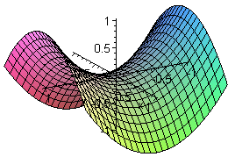Note: At this step any analytical surface could be defined for the contact. Ideally a saddle surface would best fit a usual interpenetration shape.
6. Once the surface is defined, a vector from the central point to each interpenetration point is calculated. Then:
   1. The projection of the central node-interpenetration node vector along the surface normal is calculated.
   2. Then the penetrating node is moved along this vector to the surface.
7. Step 6. Is done for every penetrating node for each tow until all the penetrating nodes lie along the same surface. The result can be seen below:

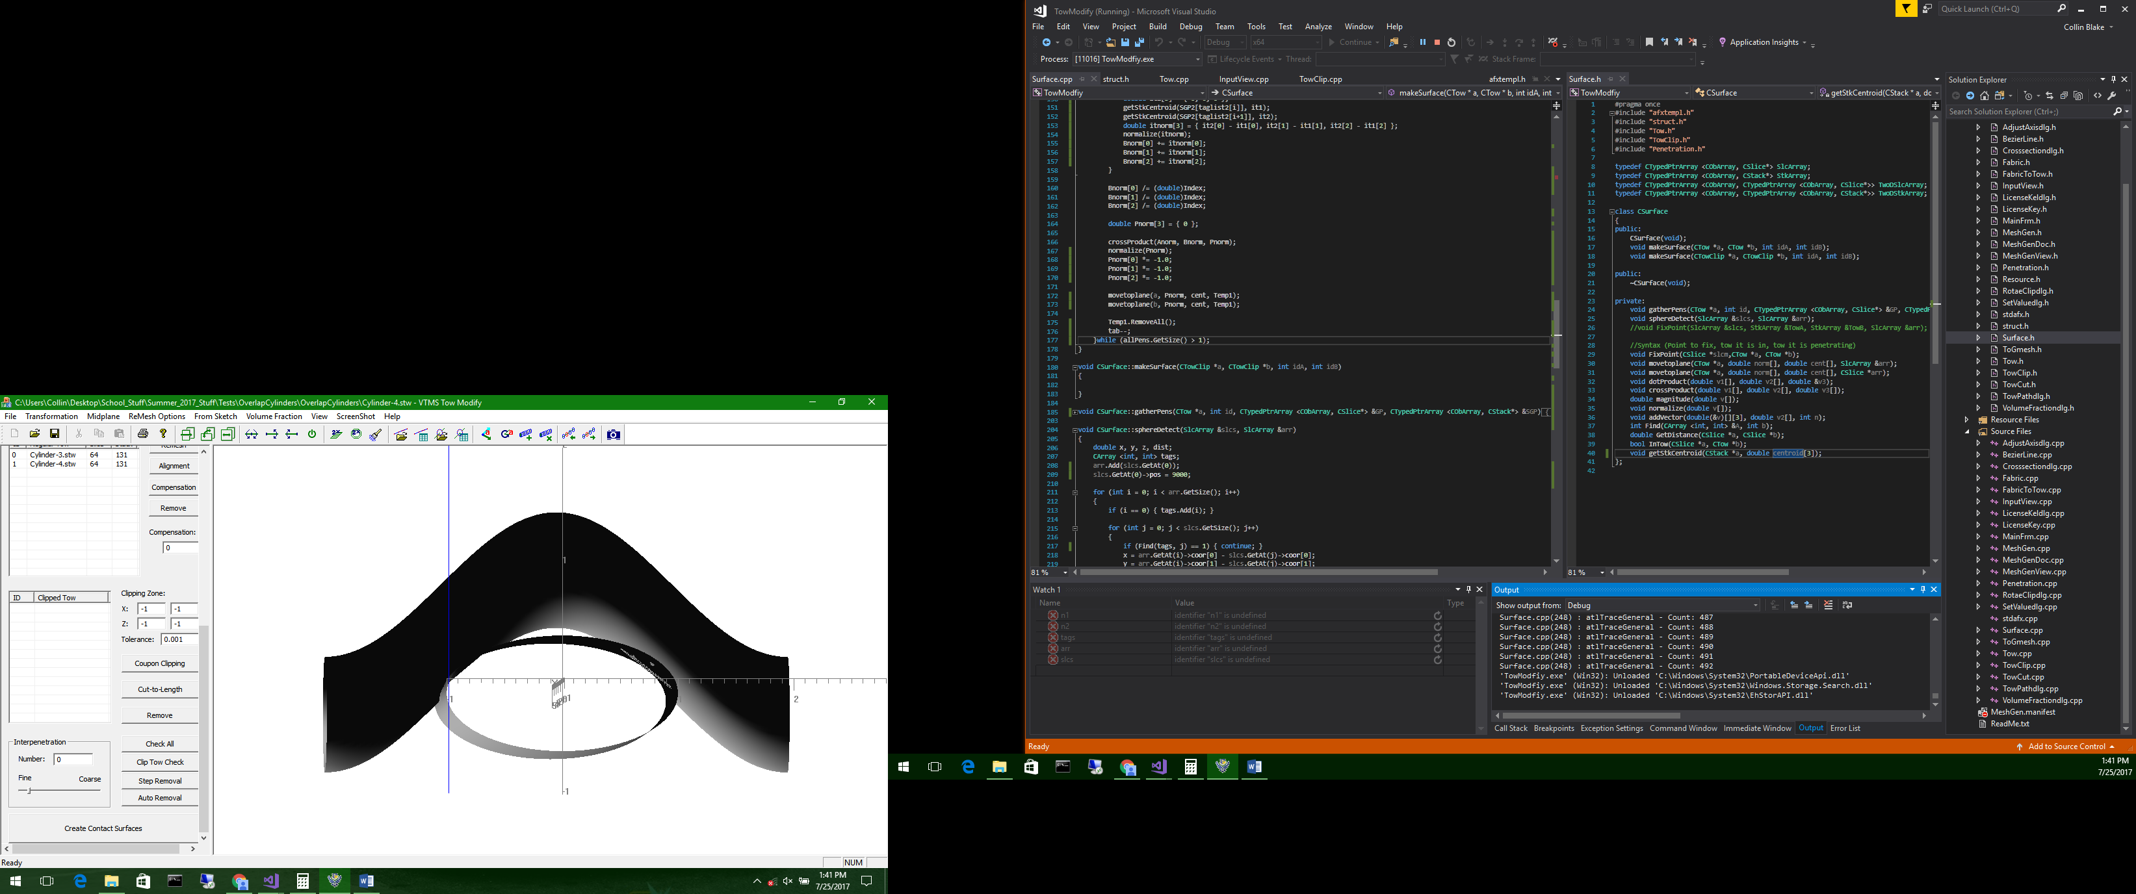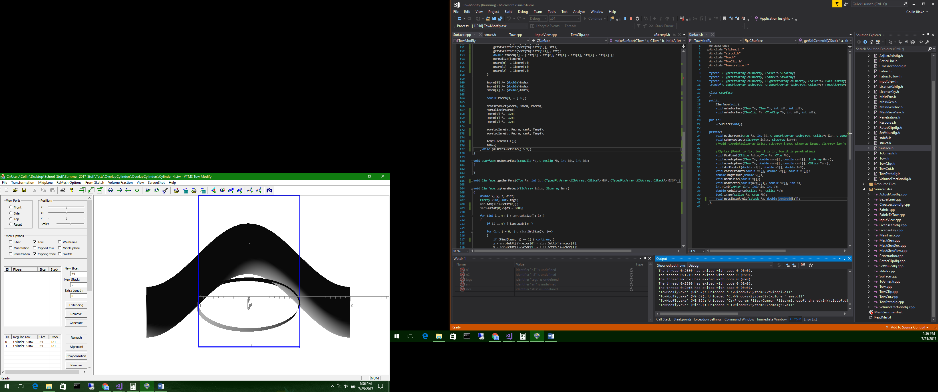

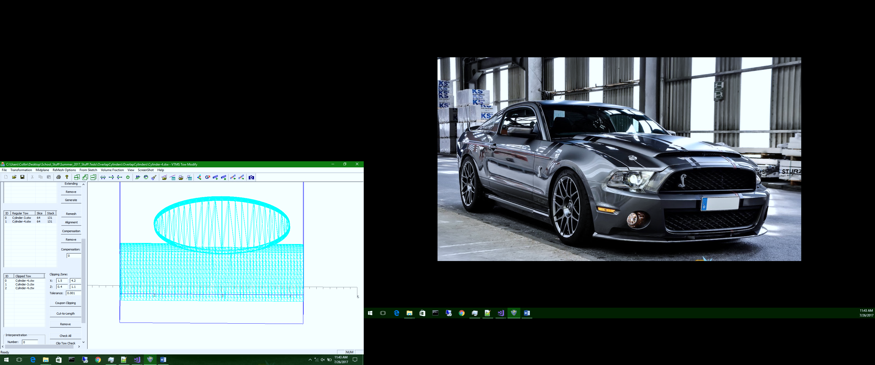

Conclusion: This method works great for multiple penetration regions between tows. The currently limitations are that a.) this algorithm only works currently for creating flat surfaces between tows and b.) does not ensure compatibility of tow meshes along contact region.

### Method 2: Node-to-Node half distance compatibility solution

This method came about as a solution to the lack of compatibility between the two tows along the contact surface. The hope is that the result of this method would result in compatible meshes between the tows, however the surface could possibly be ragged and unrealistic. This method also would allow for any surface mesh to be used (i.e. VTMS’ .ctw file), not just the standard tow format of the data.

1. The method for identify the interpenetrating nodes is the same as listed above.
2. Once the nodes are collected, each interpenetrating node undergoes this process:
   1. A sphere is created to detect the closest node on the opposing tow that is interpenetrated
   2. The distance between the two nodes along with the vector pointing from one to the other



* 1. The two nodes (one from tow 1 and tow 2) are moved to the midpoint along this vector so that the are in the same place.



* 1. This is done for all nodes on both of the tows until there are no remaining interpenetrations.

1. The result is fairly rough contact region between the two tows. The method is also unpolished as can be seen below where some nodes are moving when they are not required to, resulting in very jagged edges. Also, there is no protection against collapsing elements as the nodes move around and to each other. Therefore, this method is still incomplete.

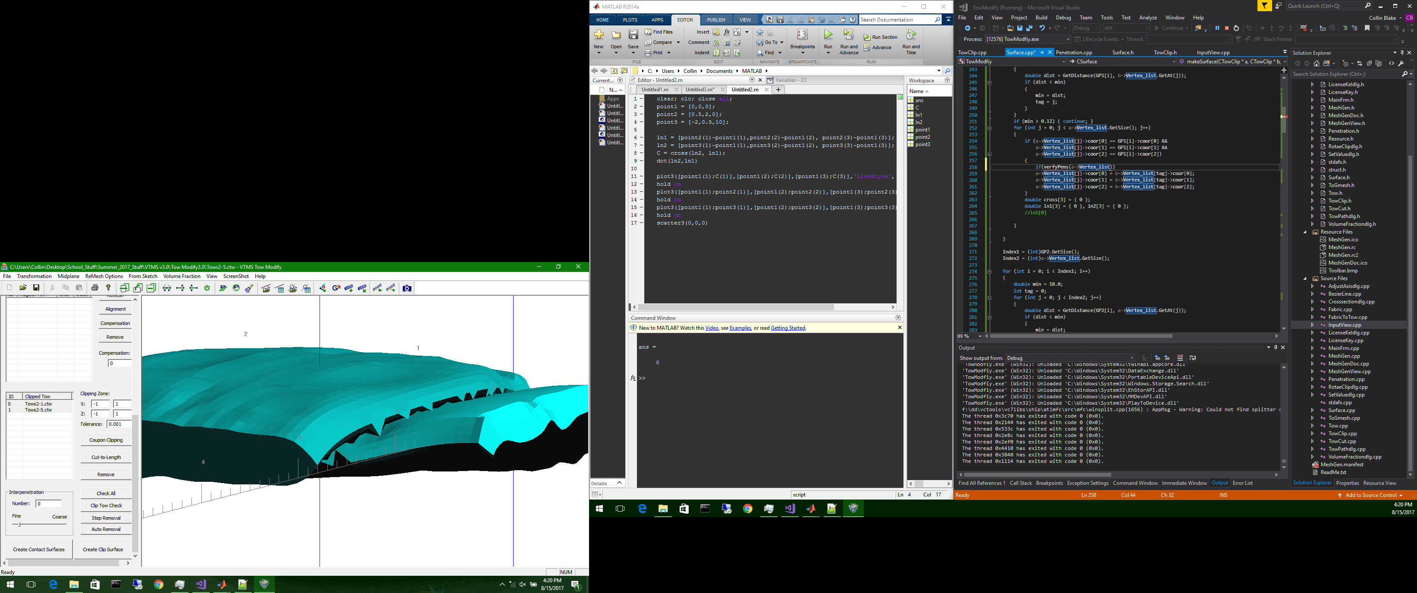

This concludes the accomplished methods for the discrete representation.

# Non-Uniform Rational B-Spline Surface Strategy

Once the methods for the discrete representation had been explored, a new method was explored concerning the conversion of the surface mesh into an analytical representation. A discussion of NURBS will happen at a later date. For this outline, it is sufficient to say that a NURBS is a curve that can be combined with multiple curve of the same order to form complex shapes and surfaces with parametric coordinates. In this way, complex point data can be combined into an analytical representation of the data.

Starting mesh information:

* Same as above

## Detection of Interpenetration Regions

This algorithm utilizes a NURBS library titled SISL and is from SINTEF ICT, Department of Applied Mathematics.

Method:

1. First, the data from a VTMS .stw is imported for each tow. This format is very beneficial for this library as it is formatted perfectly for parametric coordinate systems. Each tow cross-section stack has 64 nodes and has x number of stacks. This way the data ports directly into the library to create a NURBS representation for each tow.

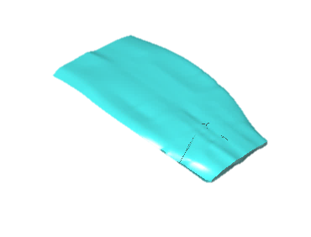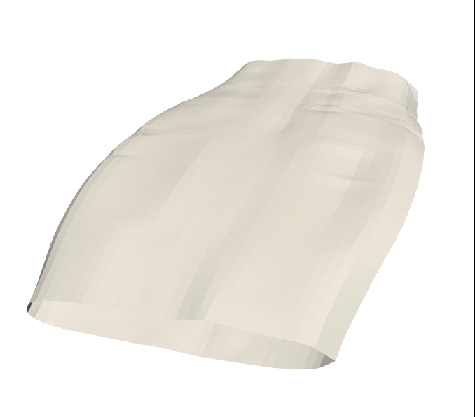

NURBS Rep Mesh Rep

1. Then, still using the SISL library, a function call is made to analyze each pair of representations for any interpenetration regions. The function will return boundary curves that trace where the two representations intersect. This then describes the interpenetration regions. The curves are not particularly ordered, closed, or use the same curve points to describe curves that potentially overlap. Therefore, some processing is needed.
   1. First, we convert each curve into a line segment mesh to perform any mesh operations that we need. These operations come from our own developed BetaMesh. The conversion samples points along the boundary curve and then uses the returned locations to create nodes for the mesh.
   2. We then check each boundary curve mesh node to see if aligns, overlaps, or connects with any other curve mesh.
      1. Take node to check, and boundary curve segment to test along, and determine if node lies on segment
      2. If so, combine both meshes to create a single mesh
      3. If not, continue along curve nodes.
   3. The result is closed, unique boundary curves.

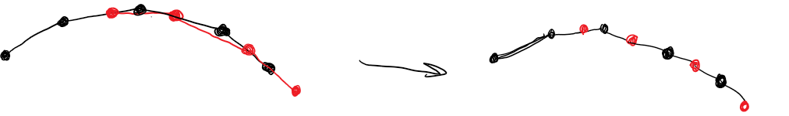

*Red and black curve segments that originally overlap combined into single curve*

Note: Step 2 is the end of the NURBS representation. At this point we will use a mesh of the tow to discover and fix the interpenetration regions.

1. Once we have correct boundary curves, we can use them to identify the elements of the tow meshes that are part of the interpenetration region. The algorithm is as follows:
   1. Begin by looping over all curves, and each segment for current curve.
   2. For each segment, using a KD Tree, determine the 8 (maximum number of elements a segment could interact with at once) closest tow elements and determine if the segment intersects the element via the Separating Axis Theorem
      1. SAT states that for any two 2-D shapes, there exists an axis along which the bounds of the shape do not overlap if they do not intersect. (App. A)
      2. We employ this by first projecting the boundary curve segment onto the plane of the 2-D tow mesh element.
      3. We then employ the SAT and return true if they intersect
   3. If the segment and tow mesh element intersect, we then calculate the point where the (projected) segment crosses the element and define it as an intersection point.
   4. We then add this intersection point to the boundary curve mesh and subdivide the segment so that it has a point that lies on the edge of an element. The reasoning is so that along this boundary curve, there will be a point of compatibility that coincides with every element that the boundary curve crosses.
   5. We conduct this algorithm for both tow meshes for which the interpenetration region lies.
   6. 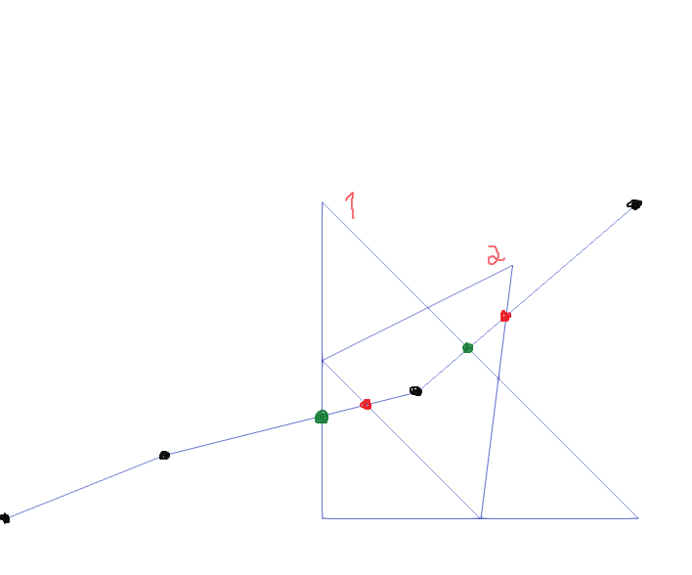The result is boundary curves that have nodes that lie on every element edge that they intersect for both tows so that there is base line for compatibility of the meshes of each tow.
   7. We also determine the elements that are intersected by each curve for each tow mesh and create element sub groups that can be referenced at a later date.
2. This ultimately concludes the detection portion of this method. It should be noted that at this point we can return both the boundary curve meshes as well as the tow meshes and certain tow element groups that have been intersected by the interpenetration boundary curves. To this point, this is what we have completely accomplished.

## Solution to Interpenetration Regions.

Still a work in progress. I have, to the best of my abilities, described the desired solution and result we are working towards.

Method:

1. We begin by selecting a boundary curve. For each tow mesh, we select the corresponding element group that is intersected by this curve. Then, iterating over each element:
   1. The boundary curve segments that lie inside the element are collected.
   2. The intersection points that lie on the element edges are also collected.
   3. 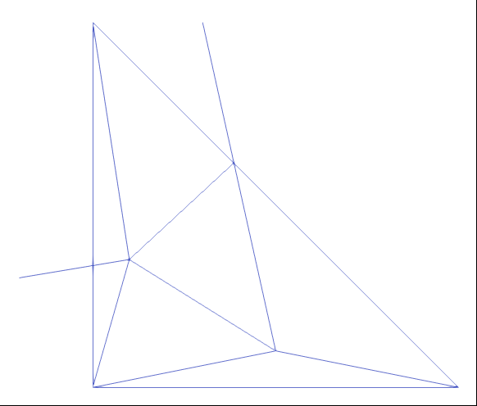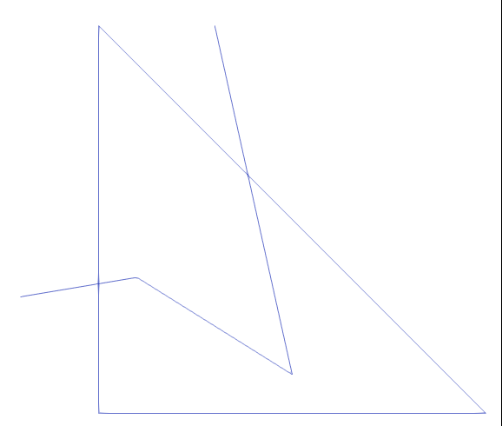These segments and points are used in conjunction with the Triangle meshing library from UC Berkley to create a sub mesh that uses both the original tow mesh element nodes along with the boundary curve segment nodes. This creates a compatible mesh between the elements of the tow mesh that are connected to the intersected tow mesh element and the boundary curve segments.
2. This is done for every intersected tow mesh element on each tow to create tow meshes that are compatible exactly along the boundary curve that defines the interpenetration region.
3. The result is two tow meshes that are not yet compatible but share a collection of element edges that also defines the boundary of where the tow meshes originally intersected each other.

***From here on is speculation. I will attempt to make clear what we plan to do and what could be done at a later date by an interested party.***

1. (**Planned to finish)** We must next determine the collection of tow mesh elements line inside of the interpenetrating region and which do not. This can be accomplished by:
   1. Starting at an edge along the boundary curve.
   2. Selecting the elements that share this edge and storing them in different groups.
   3. For each element, determine the connecting elements via which elements share an edge with the initial element and add that element to the group that the initial element was a member of.
   4. Check the new element to see if it shares an edge with the boundary curve. If so, do not add the element that shares that edge with the new element.
   5. After all elements have been evaluated, the group with the largest surface area is determined to not be in the interpenetrating region.

As step 4. Is difficult to understand verbally, an example.



1

2

3

4

5

6

7

8

9

10

Imagine we start at the line segment between elements 1 and 6. Element 1 is assigned to group green and element 6, group red. Then, starting with 1, we find that elements 6, 2, and 10 are connected. We check 6 and discover that the edge it shares with 1 is also a boundary curve segment, so we do not add it. Element 10 also has a edge along the boundary curve however it is not the same edge it shares with 1, so we add it to green group. 2 does not share and edge with the boundary curve, so it is added to green as well. For 2, we find it is connected to 1,3, and some element not shown. We already know where 1 belongs so we check 3. Again, it shares an edge with the boundary curve, but it is note the same edge it shares with 2, so it is added to green. For element 10, it shares edges with 1 and 9. 1 is accounted for but 9 is not. However, the edge that 9 shares with 10 is also a boundary curve segment, so 9 will not be added to green. In this manner, we can begin sorting elements into groups.

After 4, a couple of options are possible.

1. A simple Boolean approach could be taken where one tow mesh inside the interpenetration region is thrown out. Then the other tows interpenetration region can be used to replace the thrown-out mesh. Now both tows have a compatible mesh that is the same surface.
2. The more realistic approach would be to perform some variety of contact analysis to determine a contact surface between the two tows. Knowing which elements to perform such an analysis on as well as the boundary of the interpenetrating region will be extremely helpful in creating a solution for each specific region where otherwise the computational cost would be too great.

# Outline for Parallel Discussion of Methods

VTMS

Clipped Tow

* More typical surface mesh data
* Used by algorithm that forces node-node compatibility

Standard Tow

* Used by method that results in a contact surface (Method 1 of direct surface mesh)
* Output file type (.stw) used by NURBS

**Compatible surface algorithm (Surface Mesh) (Method 1)**

**Compatible surface algorithm (Surface Mesh) (Method 1)**

**Node-Node forcing method**

**(Method 2)**

Uses .stw and SISL library to create an analytical representation of the surface. Library then used to detect region of interpenetration. We developed algorithm to combine curves, find elements, detect intersection, etc.

**Detection**

Both algorithms use the same detection algorithm that is based off of using plane (surface triangle for method 1, surface polygon for method 2) and finding whether a tow surface node lies within another tow. The method varies slightly but is close enough to be considered the same

Solution is to identify node pairs, one on each tow, from known interpenetration nodes, and move the nodes to the same location that is along the vector that connects them This forces compatibility along the connection between the tows while removing interpenetrations

Solution is to used identified interpenetrated nodes and create an average planar surface to pull the nodes to. Creates flat surface that eliminates interpenetration. Details above

Solution consists of sub-meshing intersected elements, and identifying elements contained in interpenetration region. Solution can then either be Boolean, contact analysis, or even an average surface

**Resolution**

# Appendix A: Separating Axis Theorem

